**DATA SCIENCE – BWT – WEEK – 2**

**TASK – 4**

**SAIFULLAH KHAN**

**All about Python 🐍 Introduction, Syntax, Variables, conditions and operators**

**INTRODUCTION:**

Python is a high-level, interpreted programming language created by Guido van Rossum in 1991. Known for its simplicity and readability, Python supports various programming paradigms, including procedural, object-oriented, and functional programming. Python is widely used in web development, data analysis, artificial intelligence, and more, making it a versatile and powerful tool for developers.

**SYNTAX:**

Here are some basic syntax elements of python:

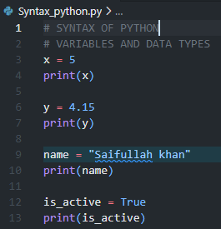

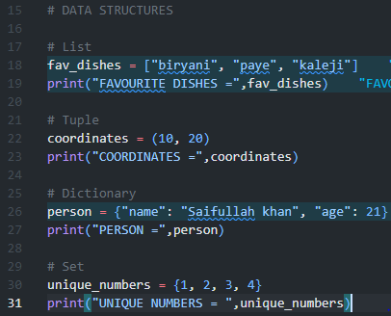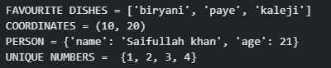

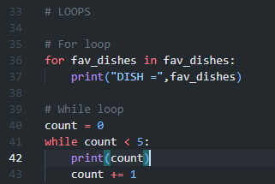  
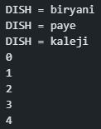

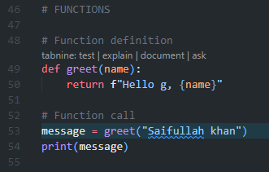  


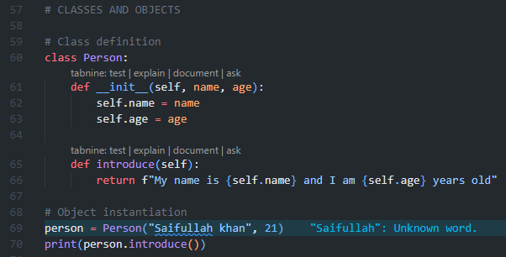

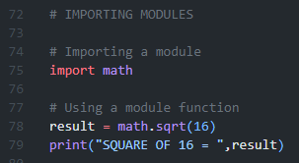  


**VARIABLES:**

In Python, variables are used to store data values. Here are some key points to variables in Python:

**Dynamic Typing:**

Python is dynamically typed, meaning you don't need to declare the type of a variable explicitly. The type is inferred from the value assigned.

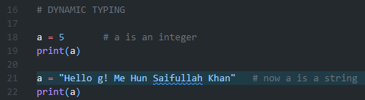

### Naming Conventions:

* Variable names must start with a letter or an underscore ( _ ).
* They can contain letters, numbers, and underscores.
* Variable names are case-sensitive (e.g., age and Age are different variables).

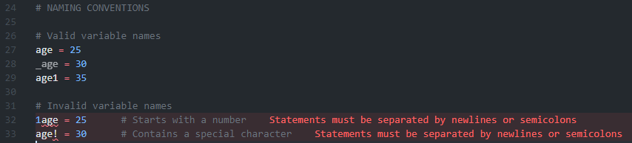

### Multi-variable Assignment:

You can assign values to multiple variables in a single line.

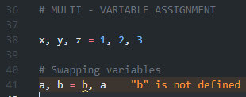

### Constants:

By convention, constants (variables that should not change) are named using uppercase letters.

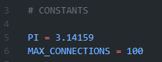

### Checking Variable Types:

You can check the type of a variable using the type() function.

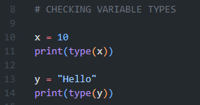  


### CONDITIONAL STATEMENTS:

Conditional statements in Python allow you to execute different code based on certain conditions.

# IF STATEMENT

saif_age = 5

if saif_age < 7 :

    print("Saif is too young to go to school")

# IF-ELSE STATEMENT

saif_age = 16

if saif_age < 10 :

    print("Saif is too young to go to school")

else:

    print("Saif is now good to go to school")

# ELIF STATEMENT

saif_age = 10

if saif_age < 10 :

    print("Saif is too young to go to school")

elif saif_age == 10:

    print("Saif's age is to play and grow but not to go to school now")

else:

    print("Saif is now good to go to school")

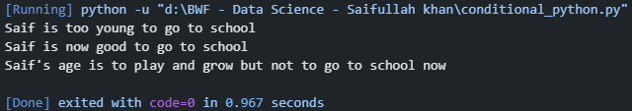

### OPERATORS:

Operators in Python are used to perform operations on variables and values.

**Arithmetic Operators:**

# ARITHMETIC OPERATORS

x = 10

y = 15

add = x + y                                   # Adds two operands

print("ADDITION =",add)

sub = x - y                                   # Subtracts two operands

print("SUBTRACTION =",sub)

mul = x * y                                   # Multiplies two operands

print("MULTIPLICATION =",mul)

div = x / y                                   # Divides two operands

print("DIVISION =",div)

mod = x % y                                   # Returns the remainder of the division

print("MODULUS =",mod)

exp = x ** y                                  # Raises the first operand to the power of the second

print("EXPONENTIATION =",exp)

floor_div = x // y                            # Returns the floor of the division

print("FLOOR DIVISION =",floor_div)

